Kids today: Changes in school-readiness in an early childhood era

Daphna Bassok

University of Virginia

Scott Latham

University of Virginia

Abstract

Public investment in early childhood education has expanded dramatically in recent years. Despite this investment, we have little empirical evidence on whether children today know more at school entry than they did two decades ago. Using two large, nationally representative datasets, this paper documents how students entering kindergarten in 2010 compare to those who entered in 1998 in terms of their proficiency in reading and math and their behavioral skills. Our results indicate that students in the more recent cohort entered kindergarten more proficient at both reading and math skills. Improvements over this period were particularly pronounced among black and Hispanic students as well as low-income children.

*Keywords:* school readiness, achievement, early childhood, student cognition

**Kids today: Changes in school-readiness in an early childhood era**

Public investment in early childhood education has expanded dramatically in recent years. Between 2001 and 2013 state spending on preschool initiatives nearly doubled from $2.4 to $5.4 billion and over the past two decades the number of students in public preschool has also nearly doubled. Many states have recently introduced early learning standards, more restrictive quality regulations for early childhood education providers, and Quality Rating and Improvement Systems (QRIS) that incentivize quality improvements in early childhood settings.

Despite the unprecedented interest and investment in early education, we have little empirical evidence on whether children today know more at school entry than they did two decades ago and whether they are more “ready to learn” than they were in the past. Although datasets like the National Assessment of Educational Progress (NAEP) have long allowed researchers and policy-makers to track changes over time in the achievement of nationally representative cohorts of elementary, middle and high-school-aged students, until now we have had no data that would allow for comparisons across cohorts of children at kindergarten entry. The current paper aims to fill this gap.

Using two nationally representative samples of children entering kindergarten in

1998 and 2010 this paper asks three related research questions:

1. To what extent do children who entered kindergarten in 2010 differ from those who entered school in 1998 with respect to teacher-reported measures of literacy and mathematics knowledge?
2. Do changes in school readiness over time differ across racial and socio-economic subgroups leading to changes in school-entry achievement gaps?
3. Is there evidence that children who entered kindergarten in 2010 differ from those who entered school in 1998 with respect to non-academic measures?

**Background**

Children’s early academic skills are strongly predictive of outcomes well into the future, including college attendance, home ownership, earnings, and retirement savings, and children who start behind typically continue to lag (Chetty et al., 2011; Duncan et al., 2007). Further, it is well documented that by kindergarten there are already large achievement gaps based on race and income, and that these gaps persist as children proceed through school (Fryer & Levitt, 2004; Reardon, 2011).

Over the past two decades a large body of evidence from education, developmental psychology, neuroscience, and economics has demonstrated that early childhood is a particularly malleable time in the life course and that interventions targeted towards this period can have both long-lasting and cost-effective impacts (Bassok & Loeb, 2015; Heckman, 2006; Shonkoff & Phillips, 2000). Early childhood programs are seen as a promising strategy for improving children’s learning trajectories and reducing income and achievement gaps. By providing a stimulating and enriching environment for children in the years before kindergarten, they potentially prevent gaps from developing, or mitigate their severity. Indeed, a large body of evidence suggests early childhood programs can have important short and long term benefits (Camilli, Vargas, Ryan, & Barnett, 2010; Campbell et al., 2012; Deming, 2009; Schweinhart et al., 2005; Weiland & Yoshikawa, 2013)

In light of the rapid expansion of public early childhood education over the past two decades, one plausible but untested hypothesize is that children who entered kindergarten in 2010 had more exposure to academic material and therefore had more advanced pre-literacy and mathematics skills than those who entered in 1998. This hypothesis is consistent with recent evidence that parental investment in children during the early childhood years is on the rise and that academic expectations among kindergarten teachers have escalated rapidly (Bassok, Latham, & Rorem, 2014; Kornrich & Furstenberg, 2013).

Although several states have instituted universal preschool programs over the period examined, the majority of public early childhood programs are targeted towards low-income students (Barnett, Carolan, Squires, & Brown, 2014). If relative to their peers low-income families experienced greater improvements with respect to access and quality of early childhood education opportunities, we might expect to see that improvements in academic school readiness over the past decade and a half are particularly pronounced among low-income and minority children.

Expected changes over time with respect to children’s behavior are more ambiguous. On the one hand, if more children are experiencing preschool in the year prior to kindergarten entry, perhaps they enter kindergarten more accustomed to classroom norms and behavioral expectations. On the other hand, earlier research demonstrates that preschool participation is negatively associated with measures of social skills in subsequent years (Belsky et al., 2007; Loeb, Bridges, Bassok, Fuller, & Rumberger, 2007). Researchers have also hypothesized that early exposure to very structured literacy or math curriculum in early childhood may be associated with stress or problem behaviors (Stipek et al., 1998; Stipek, Feiler, Daniels, & Milburn, 1995).

**Methods**

**Data**

The National Center for Education Statistics (NCES) recently released the first two waves of data tracking a nationally representative cohort of children who entered kindergarten in the fall of 2010 (the Early Childhood Longitudinal Study – Kindergarten 2010 cohort, or ECLS-K 2010). This new dataset contains measures that are directly comparable to the original ECLS-K study, which tracked a cohort of children who entered kindergartener in 1998 (West, Denton, & Germino-Hausken, 2000; West, Denton, & Reaney, 2001). The release of this new data provides a unique opportunity to assess whether there have been nationwide changes in school readiness, both for the overall population and for specific subgroups, over a period characterized by heightened investment in early childhood.

Each dataset was collected using a multi-stage probability sample design; children were selected from schools which were first selected from “primary sampling units” (counties or groups of counties). Schools and primary sampling units were both chosen with probability proportional to size. Both datasets include direct student assessments along with surveys of parents, teachers, and school administrators. Parents and teachers were surveyed in both the fall and spring of the kindergarten year (Tourangeau, Nord, Lê, Sorongon, & Najarian, 2009). The original ECLS-K followed students through 8th grade, and the 2010 cohort will be followed through fifth grade. We limit our sample to first-time kindergarteners in each cohort and our analytic sample includes approximately 16,000 students in 1998 and 13,500 in 2010 (all sample sizes rounded to the nearest 50 in accordance with NCES guidelines.)

We conduct multiple imputation using chained equations to avoid the bias that may arise when analyzing complete-case data. Our imputation model accounts for all the covariates that we later include in our analysis (i.e. demographics, home environment, and teacher/classroom variables), and we impute independent but not dependent variables. Multiple imputation was conducted using the MI command in Stata, and five imputed datasets were generated.

**Measures of school readiness.** The ECLS-K datasets contain diverse measures of children’s school readiness including direct and teacher-reported measures of early literacy and mathematics knowledge, as well as teacher-reported measures of children’s behaviors. For the purposes of this paper, we focus primarily on teacher-reported measures and separate these outcomes into cognitive (language development and math) and behavioral (i.e. social-emotional development, approaches to learning)

***Cognitive outcomes*.** To capture student language development and math knowledge, both ECLS-K datasets collected teacher-reported measures of student proficiency across multiple domains encompassing a broad range of reading and math skills. In the first months of kindergarten (September-December), teachers were asked to rate each child’s proficiency in the following domains on a scale from 1 (“Child has not yet demonstrated skill”) to 5 (“Child demonstrates skill competently and consistently”):

Math skills

* Sorts math materials by various rules and attributes
* Orders groups of objects (by height, color, etc.)
* Understands relative quantities
* Solves problems using numbers
* Understands graphing activities
* Uses instruments accurately for measuring
* Uses a variety of strategies to solve math problems

Language and literacy skills ("Reading")

* Uses complex sentence structures
* Understands and interprets stories read to him/her
* Easily names all upper and lower case letters
* Predicts what will happen next in stories
* Reads simple books independently
* Demonstrates early writing behaviors
* Understands conventions of print

We analyze changes over time in each of these proficiency outcomes individually, and also consider three summary measures. First, we consider each child’s average skills in math and reading. We also examine changes at the tails of the distribution. To do this, we divided the total number of skills at which each student was rated either highly proficient (5) or not proficient (1) by the total number of skills. The resulting variables can be interpreted as the percent of skills for which each student is at the top or bottom of the distribution, respectively.

Two concerns about the teacher-reported measures of skills are worth highlighting. First, because data were collected during the first few months of kindergarten these teacher ratings are not “pure” measures of student knowledge at school entry and may be capturing, in part, skills gained during the beginning of the school year. This concern is lessened because the data collection period is extremely similar across the two studies. We also control for month of assessment in all analyses.

Second, although changes over time in teachers’ ratings of children’s skills may accurately capture true changes in the skills that children bring into the classroom, they could also capture changes over time in how teachers perceive children or in teacher’s approaches to assessing children. Ideally, we could supplement our examination of teacher-reported assessments of students’ skills with direct assessments. However, although both waves of the ECLS-K include direct student assessments of children’s reading and math ability, the datasets are not comparable across the two cohorts and no cross-walk is currently available.

That said, existing research demonstrates that teachers’ assessments of students’ cognitive skills are strongly correlated with both current and future direct assessments (Hecht & Greenfield, 2001; Teisl, Mazzocco, & Myers, 2001). This pattern certainly holds in both waves of the ECLS-K. Appendix A shows that in 1998, teacher-reported measures of children’s early readiness skills are predictive of direct assessments not only in kindergarten but all the way through eighth grade. Correlations between teacher-reported ability and direct assessments in kindergarten are similar in 1998 and 2010.

***Behavioral outcomes*.** In the fall of the kindergarten year, teachers completed a version of the Social Skills Rating System (Gresham & Elliott, 1990), a widely used assessment of social and emotional development, along with approaches to learning. Respondents were asked to rate the frequency of different types of student behavior on a scale from 1 ("Never exhibits behavior") to 4 ("Exhibits behavior frequently"). The ECLS-K datasets do not contain item-level responses. Instead, items were combined into “subscales” that measured different dimensions of student behavior. The teacher survey included five subscales measuring self-control, interpersonal skills, externalizing problem behavior, internalizing problem behavior, and approaches to learning.

**Demographics & Covariates.** A key strength of the ECLS-K datasets is that they provide unusually rich information about children and their families. We disaggregate our analysis by race and a measure of socioeconomic status constructed from parental income, education, and occupational prestige. In addition, our models account for demographic characteristics that may be correlated with children’s early development including age, gender, whether the child was born in the U.S., whether they are U.S. citizens, whether English is primarily spoken (or spoken at all). We also account for urbanicity of the child's community (city/suburb/rural) and the region of the country. Descriptive statistics for these demographic variables are presented in Appendix B.

In addition to these demographic measures, in a final set of analyses we consider three categories of factors that might influence teachers’ ratings of children’s school readiness: children’s access to early childhood education programs, aspects of the home environment, and kindergarten teacher and classroom characteristics. To measure access and exposure to early childhood education we use parent- and principal- reported measures of the type of care their children received in the year prior to entering kindergarten. Specifically, we account for whether a child attended "formal" care defined as either Head Start or center-based care, the number of hours children spent in formal care each week, whether children attended kindergarten and prekindergarten in the same building, and whether the child's kindergarten school also offers prekindergarten.

The ECLS-K data provides a number of measures of parental engagement with children around learning behaviors. Parents were asked about the frequency with which they do activities with their children, such as reading books, playing games, and doing chores. Parents were also asked to rate the extent to which they think a number of skills are important for school readiness. These skills include counting to 20, knowing the letters of the alphabet, sharing with others, using a pencil, paying attention/sitting still, and communicating needs/wants verbally. Finally, kindergarten teachers reported detailed information about their demographics, teaching experience, and education. They also provided information on the demographic composition of their classrooms.

**Analysis**

We compare measures of school readiness over time using a regression framework. The first set of models takes the form:

yi = β0 + β1ECLS2010i + β2Agei  + εi (1)

Here, *yi* is either a cognitive or behavioral outcome for student *i* at kindergarten entry, and *ECLS2010i* is an indicator variable set to 1 if student *i* was part of the 2010 ECLS-K cohort, and set to 0 if the student was part of the 1998 cohort. *Agei* represents student *i*’s age in months both when they entered kindergarten and when they were assessed. This controls for potential differences in age across cohorts that may be confounded with differences in cognitive and social abilities. *εi* represents an error term with mean 0. *β1*is the coefficient of interest, and it provides an estimate of the (age-adjusted) difference across cohorts for each outcome variable. We also employ probability weights that adjust for non-response, making the results nationally representative. Standard errors are clustered at the teacher level.

After describing the raw magnitude of the changes over time, we run models that assess whether these changes are explained by differences across the cohorts in demographic composition or other factors that may be associated with school readiness. These models take the form:

yi = β0 + β1ECLS2010i + β2Agei + β3Demographicsi’ + β4Preschooli’ (2)

+ β5Beliefsi’ + β6Activitiesi’ + β7Kindergarteni’ + εi

Here, *Demographicsi’* is a vector of demographic characteristics (e.g. race, SES, English

speaking), *Preschooli*’ is a vector of variables that relate to preschool attendance, *Beliefsi*’ and *Activitiesi*’ are vectors of parental beliefs about the importance of different skills for school readiness, and activities that students and parents participate in at home*. Kindergarteni’* includes characteristics of the kindergarten teacher and classroom. Again, *β1* is the coefficient of interest, specifically in comparison to the *β1* estimated in model (1). Large differences in this coefficient across models would suggest that changes in student outcomes were driven at least partly by the included covariates. We include these different sets of characteristics one at a time, to determine their individual impact on our estimates, and also include them all together, to explore the total portion of the changes that are explained by these observable measures.

Finally, we also examine whether differences in student outcomes across cohorts vary by race and socioeconomic status. This analysis is an extension of model (1) and takes the form:

yi = β0 + β1ECLS2010i + β2Agei + β3Xi’ + β4ECLS2010i * Xi’ + εi (3)

Where *Xi’* is a vector of indicator variables representing either race or SES. In models that explore differences by race, this vector includes indicators for whether a student is black, Hispanic, Asian, or other nonwhite (omitting white). In exploring SES, the vector includes the lowest four SES quintiles (omitting the highest quintile). *ECLS2010i * Xi’* is a vector of interactions between each subgroup and membership in the 2010 cohort. Here, the coefficients of interest are the vector of β4s, which estimate the extent to which differences in school readiness between cohorts differed by race and SES. These coefficients can be interpreted as changes in school readiness relative to white students and students in the highest SES quintile, respectively.

**Results**

**Changes in academic skills at school-entry**

Figure 1 presents the distribution for four sample measures of kindergarten readiness (e.g. reads simple books independently, understands relative quantity). The blue bars show the distribution of these skills in 1998 and the clear bars show the distribution in 2010. In all cases we observe the distribution shifting to the right, indicating that in 2010 teachers reported stronger academic skills for their incoming kindergarteners relative to 1998. The pattern is particularly pronounced for letter recognition. In 1998, approximately a quarter of children were rated by their teacher as “not yet” demonstrating that skill, and 15 percent were demonstrated the skill consistently. By 2010, the distribution reversed with only 15 percent entering not yet recognizing letters and 25 percent doing so consistently. Appendix C shows similar figures for all the literacy and math outcomes considered, and shows that to varying degrees this pattern is consistent across all items considered.

The findings in Table 1, which presents changes over the period in our aggregated measures of readiness, mirror these patterns. In column 1 we show results that only control for student age at kindergarten entry. Strikingly, students in the 2010 cohort were rated about .25 SD higher on both reading and math skills than their 1998 counterparts. Changes were apparent throughout the ability distribution; in both reading and math we see drops in the average percentage of skills that children were given the lowest rating (not yet) and an increase in the percentage of skills that children were given the highest rating (consistently demonstrating). The next two columns present results from increasingly saturated models. Our findings are essentially unchanged when we control for demographic characteristics (column 2), and appear strikingly robust to the inclusion of a rich set of variables including measures of preschool participation, parenting practices and kindergarten characteristics.1

**Differences in patterns across race and socio-economic status**

Figure 2 shows how teacher-reported math proficiency changed over time disaggregated by race and SES. We present the mean percent of skills that children had “not yet demonstrated” as well as the mean percent they “demonstrated consistently.” Appendix D shows analogous results for literacy. A few patterns emerge. First, across both math and reading, we see that white children are rated as having higher kindergarten readiness skills relative to Black and Hispanic children, and similarly that children in the top quintile of SES are rated substantially higher than those in the bottom quintile.

The figures also indicate that teachers ranked *all* groups higher in 2010 than in 1998. For all subgroups considered we see drops in the percentage of children in the lowest category and increases in the percentage ranked in the highest category. Notably, the overall changes shown in this figure are more pronounced among Black, Hispanic and low-income children than among white children. For example, while the percentage of white children who received the lowest ranking on math dropped by about 3 percentage points over this period, among low-income, Black, and Hispanic children we observe a drop of between 6-9 percentage points.

In Table 2 we further examine differences in patterns across groups within a regression framework. We present results using math outcomes, and analogous reading results are available in Appendix C. We find that increases in children’s math skills at kindergarten entry are particularly pronounced among Black children. While all racial groups experienced increases over this time, the magnitude of the change for Black children was systematically larger. Although we do not see a similar interaction for Hispanic children on their overall math or reading proficiency scores, we do find that Hispanic students are moving out of the lowest rating of math (but not reading) skills at a higher rate than other groups. Accounting for demographic covariates does not change the overall results, and if anything the coefficients are larger in the fully saturated models.

The bottom panel of Table 2 shows results from models that interact membership in the 2010 cohort with socioeconomic status. Again, we find that early academic proficiency has increased across the board. However, children in the lowest quintile with respect to socio-economic status showed greater gains over this period relative to children in the top quintile. In particular, these students had higher overall math skills and also disproportionately moved out of the bottom of the distribution.

**Changes in behavior at school entry**

Table 3 shows changes in teacher-reported behavioral measures over time. In this table, each of the outcomes has been coded so that positive coefficients indicate better behavior. We find no changes on three of the five behavioral measures considered (self-control, interpersonal skills and externalizing problem behaviors.) Teachers rated children in the 2010 cohort as showing fewer internalizing problem behaviors, which measure children’s shyness or loneliness. However, they reported that children were doing worse with respect to “approaches to learning” which measures children’s ability to pay attention or adapt to changes in routines. We found no systematic differences across race and SES with respect to these outcomes.

**Discussion and Conclusions**

This study provides the first evidence we are aware of about changes in school readiness over time for a nationally representative sample. We find that children are arriving at kindergarten with a different set of skills than 15 years ago, as measured by teacher assessments. In particular, children are entering kindergarten more proficient across a variety of math and reading skills.

These changes are evident among students across race and SES and they are also evident throughout the skill distribution. That said, we find particularly large gains in teacher-reported math and reading proficiency among low-income, Black and Hispanic students. These findings are encouraging and suggest a narrowing in the “school readiness” gap. Our findings are also consistent with recent research that uses the two waves of the ECLS data leveraged here to document narrowing in school-entry racial and socio-economic achievement gaps with respect to direct measures of cognitive skills (Reardon & Portilla, 2013). Taken together, these two studies suggest that over the past decade and a half early achievement gaps are narrowing *and simultaneously* that the skills and knowledge children possess when entering school is increasing.

We also explored whether these increased math and reading skills might come at a cost in the form of worse behavioral outcomes. Our results here are mixed. We find no differences in teacher-reported behavioral outcomes with respect to self-control, interpersonal skills or externalizing behavior and actually document more favorable outcomes for internalizing problem behavior. Teachers did, however, rate the 2010 cohort somewhat less favorably with respect to their approaches to learning.

An important limitation of our study is that our outcomes are teacher-reported rather than directly assessed from students. This leaves the possibility that the changes over time we document are capturing, at least in part, changes over time in the way teachers perceive or rate skills, rather than “true” changes in children’s ability. For instance, if teachers in 2010 think a literacy skill is more important than teachers did in 1998, they may pay closer attention to this skill and systematically rate students higher (or lower) than teachers in the earlier cohort. Although we cannot address this concern directly with our data, it is unlikely our results are primarily driven by these types of teacher rating differences. In both cohorts we observe moderate correlations between teacher ratings and concurrent direct assessments, suggesting that these measures do provide a meaningful measure of children’s early cognitive skills. Further, any systematic changes over time would not account for the interactions that we observe for black and Hispanic students in 2010.

Our study raises several important questions for future research. First, do the changes we’ve documented at kindergarten entry persist? In other words, do the children in the 2010 cohort continue to outperform children in the 1998 cohort? We cannot fully answer this question until the new ECLS cohort advances further through school and a cross-walk is available to make comparisons of the direct assessments across cohorts. That said, there are several reasons to posit that the changes we document may have longer-term implications.

First, we examined whether differences across our two cohorts were still evident at the end of the kindergarten year (results available upon request). We find that differences across cohorts in teacher-rated early academic skills are even larger at the end of kindergarten than they are at the beginning. This is suggestive but encouraging evidence that these gains at entry are not fleeting. In addition, new research demonstrates that both cognitive scores measured early in childhood as well as growth in math skills in early childhood are predictive of high school outcomes (Watts, Duncan, Siegler, & Davis-Kean, 2014). This suggests that an overall increase in student ability at kindergarten entry could translate to better math skills well into the future. As data is collected from these students in future waves, we will be able to revisit this question.

The second unanswered question is one of mechanisms. We hypothesized in this paper that heightened investment in early childhood education may have led to changes in school readiness over time, particularly for low-income and minority students. However, this is only one of multiple plausible hypotheses. Changes over time could be driven by changes in parenting practices or other factors. In the current analysis we examined whether our results are sensitive to the inclusion of a long list of variables that measure parenting practices, parent beliefs about school readiness, and exposure to preschool. Our results were not driven by these measures. In our future work we hope to shed further light on the extent to which policy changes such as specific state preschool expansions explain the changes documented in the current paper.

**Bibliography**

Barnett, W. S., Carolan, M. E., Squires, J. H., & Brown, K. C. (2014). *The State of Preschool 2013: State Preschool Yearbook*. New Brunswick, New Jersey: National Institute for Early Education Research.

Bassok, D., Latham, S., & Rorem, A. (2014). Is Kindergarten the New First Grade? Documenting the rapid transformation of kindergarten and first grade. *EdPolicyWorks Working Paper*.

Bassok, D., & Loeb, S. (2015). Early Childhood and the Achievement Gap. In H. F. Ladd & M. Goertz (Eds.), *Handbook of Research in Education Finance and Policy* (2nd ed.).

Belsky, J., Vandell, D. L., Burchinal, M., Clarke-Stewart, K. A., McCartney, K., Owen, M. T., & The NICHD Early Child Care Research Network. (2007). Are There Long-Term Effects of Early Child Care? *Child Development*, *78*(2), 681–701. doi:10.1111/j.1467-8624.2007.01021.x

Camilli, G., Vargas, S., Ryan, S., & Barnett, W. S. (2010). Meta-analysis of the effects of early education interventions on cognitive and social development. *The Teachers College Record*, *112*(3). Retrieved from http://www.tcrecord.org/content.asp?contentid=15440

Campbell, F. A., Pungello, E. P., Burchinal, M., Kainz, K., Pan, Y., Wasik, B. H., … Ramey, C. T. (2012). Adult outcomes as a function of an early childhood educational program: an Abecedarian Project follow-up. *Developmental Psychology*, *48*(4), 1033.

Chetty, R., Friedman, J. N., Hilger, N., Saez, E., Schanzenbach, D. W., & Yagan, D. (2011). How Does Your Kindergarten Classroom Affect Your Earnings? Evidence from Project Star. *The Quarterly Journal of Economics*, *126*(4), 1593–1660.

Deming, D. (2009). Early childhood intervention and life-cycle skill development: Evidence from Head Start. *American Economic Journal: Applied Economics*, 111–134.

Duncan, G. J., Dowsett, C. J., Claessens, A., Magnuson, K., Huston, A. C., Klebanov, P., … Japel, C. (2007). School readiness and later achievement. *Developmental Psychology*, *43*(6), 1428–1446.

Fryer, R. G., & Levitt, S. D. (2004). Understanding the Black-White test score gap in the first two years of school. *Review of Economics and Statistics*, *86*(2), 447–464.

Gresham, F. M., & Elliott, S. N. (1990). *Social skills rating system: Manual*. American Guidance Service.

Hecht, S. A., & Greenfield, D. B. (2001). Comparing the predictive validity of first grade teacher ratings and reading-related tests on third grade levels of reading skills in young children exposed to poverty. *School Psychology Review*, *30*(1), 50–69.

Heckman, J. J. (2006). Skill Formation and the Economics of Investing in Disadvantaged Children. *Science*, *312*(5782), 1900–1902.

Kornrich, S., & Furstenberg, F. (2013). Investing in Children: Changes in Parental Spending on Children, 1972–2007. *Demography*, *50*(1), 1–23.

Loeb, S., Bridges, M., Bassok, Fuller, B., & Rumberger, R. (2007). How much is too much? The influence of preschool centers on children’s social and cognitive development. *Economics of Education Review*, *26*(1), 52–66.

Reardon, S. F. (2011). The widening academic achievement gap between the rich and the poor: New evidence and possible explanations. In G. J. Duncan & R. J. Murnane (Eds.), *Whither opportunity?* (pp. 91–116). Retrieved from http://books.google.com/books?hl=en&lr=&id=mF_me7HYyHcC&oi=fnd&pg=PA91&dq=widening+gap+reardon&ots=wrhd4OC0w8&sig=y5lNpRaFaR3awlmvBApledk8o6M

Reardon, S. F., & Portilla, X. (2013). *Trends in School Readiness at Kindergarten Entry, 1998-2010* (CEPA Working Paper). Stanford, California: Stanford University.

Schweinhart, L., Montie, J., Xiang, Z., Barnett, W. S., Belfield, C. R., & Nores, M. (2005). *Lifetime effects: The High/Scope Perry preschool study through age 40*. Ypsilanti: High Scope Press.

Shonkoff, J. P., & Phillips, D. (2000). *From neurons to neighborhoods: The science of early childhood development*. Washington, DC: National Academy Press.

Stipek, D., Feiler, R., Byler, P., Ryan, R., Milburn, S., & Salmon, J. M. (1998). Good Beginnings: What difference does the program make in preparing young children for school? *Journal of Applied Developmental Psychology*, *19*(1), 41–66. doi:10.1016/S0193-3973(99)80027-6

Stipek, D., Feiler, R., Daniels, D., & Milburn, S. (1995). Effects of Different Instructional Approaches on Young Children’s Achievement and Motivation. *Child Development*, *66*(1), 209–223. doi:10.1111/j.1467-8624.1995.tb00866.x

Teisl, J. T., Mazzocco, M. M. M., & Myers, G. F. (2001). The Utility of Kindergarten Teacher Ratings for Predicting Low Academic Achievement in First Grade. *Journal of Learning Disabilities*, *34*(3), 286–293. doi:10.1177/002221940103400308

Tourangeau, K., Nord, C., Lê, T., Sorongon, A. G., & Najarian, M. (2009). Early Childhood Longitudinal Study, Kindergarten Class of 1998-99 (ECLS-K): Combined User’s Manual for the ECLS-K Eighth-Grade and K-8 Full Sample Data Files and Electronic Codebooks. NCES 2009-004. *National Center for Education Statistics*. Retrieved from http://eric.ed.gov/?id=ED511826

Watts, T. W., Duncan, G. J., Siegler, R. S., & Davis-Kean, P. E. (2014). What’s Past Is Prologue Relations Between Early Mathematics Knowledge and High School Achievement. *Educational Researcher*, *43*(7), 352–360.

Weiland, C., & Yoshikawa, H. (2013). Impacts of a Prekindergarten Program on Children’s Mathematics, Language, Literacy, Executive Function, and Emotional Skills. *Child Development*, *84*(6), 2112–2130.

West, J., Denton, K., & Germino-Hausken, E. (2000). America’s Kindergartners: Findings from the Early Childhood Longitudinal Study, Kindergarten Class of 1998-99, Fall 1998. Retrieved from http://eric.ed.gov/?id=ED438089

West, J., Denton, K., & Reaney, L. (2001). The kindergarten year. *Washington, DC: US Department of Education*.

Notes:

We omit students from our analysis if their teachers reported that topics had not yet been introduced in their classrooms because teachers in these cases have not had a chance to assess student proficiency. However, this exclusion could bias our results if these types of students generally were less proficient than students for whom teachers provided ratings. We performed a bounding exercise to explore the extent to which this could be driving our results. For the purposes of this exercise, we assumed that all students who were missing data for a given skill were not proficient at that skill (i.e. that they were the lowest level of proficiency). We then re-ran our analysis and present results in Appendix F. The results for reading are quite similar to our main results, suggesting that these results are unlikely to suffer from this type of bias. Estimates for differences in math across time are about 60% as large as our main results. Notably, even using this extremely conservative assumption, we find meaningful differences over time in student reading and math abilities.



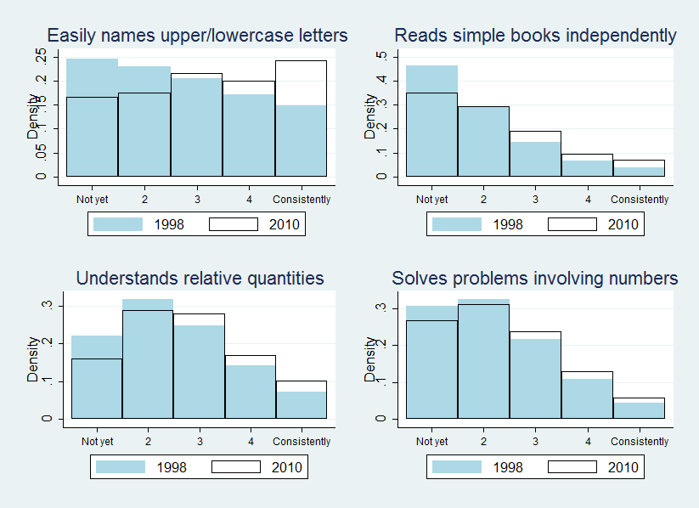**Figure 1. Distribution of selected teacher-reported literacy and math skills**

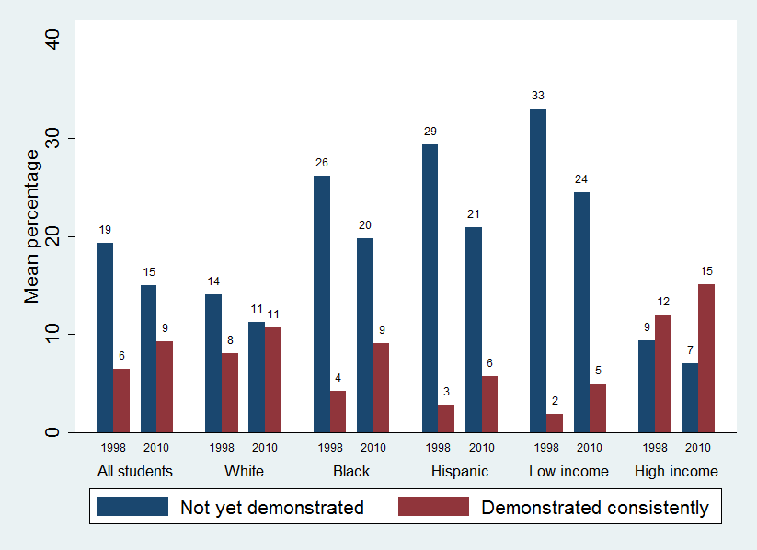**Figure 2. Percentage of math skills that entering kindergarteners had demonstrated**



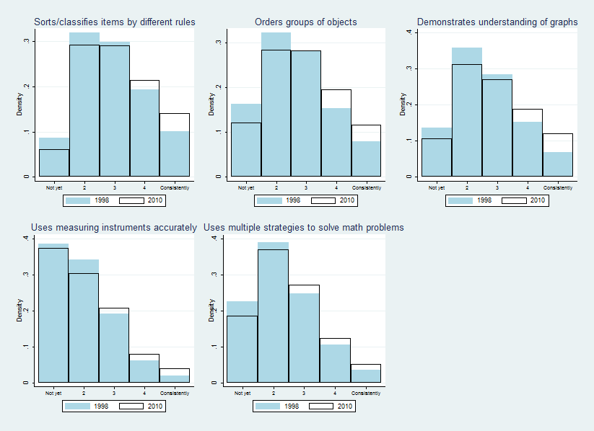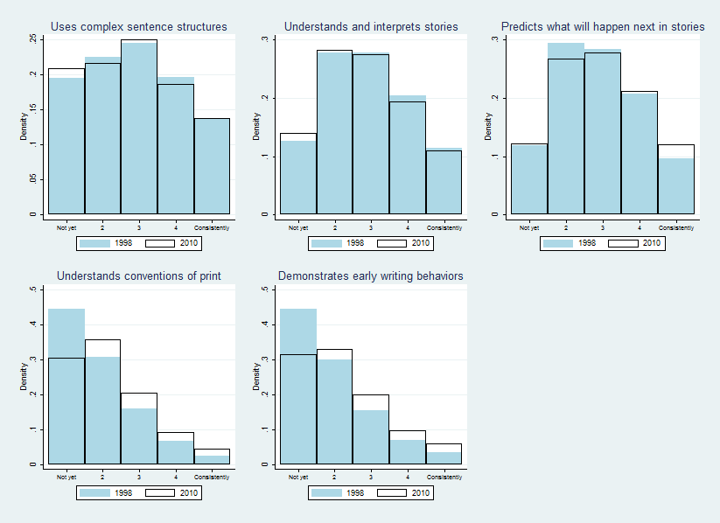**Appendix C. Distribution of additional teacher-reported literacy and math skills** **Appendix D. Percentage of literacy skills that entering kindergarteners had demonstrated**

